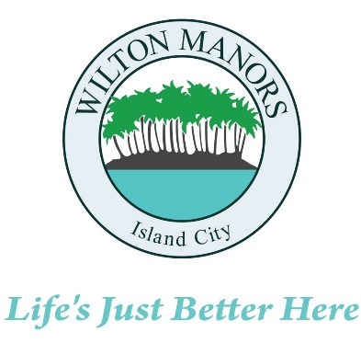
WILTON MANORS, Island City
2020 WILTON DRIVE, WILTON MANORS, FLORIDA 33305

COMMUNITY DEVELOPMENT SERVICES
(954) 390-2180 FAX: (954) 567-6069

Agenda
Development Review Committee Meeting
City Commission Chambers
City Hall
2020 Wilton Drive
Wednesday, February 18, 2026 at 8:30AM

ITEMS SCHEDULED

- Roll Call

- Public Comment:
Any member of the Public may speak on any issue for three (3) minutes.

- Approval of Minutes:
February 3, 2026

- Proposed Amendments to the City of Wilton Manors Comprehensive Plan: amendments related to Evaluation and Appraisal Review as required by Florida Statute 163.3191; addition of Property Rights Element as required by Florida Statute 163.3177(6)(i); and update to Water Supply Plan as required by Florida Statutes 373.709 and 163.3177(6)(c)3.

Reviewers: Community Development Services Department, Fire Prevention Division, Emergency Management / Utilities Department, Police Department, Building Official, Engineering Consultant, and Coastal Waste and Recycling.

The application and any backup materials may be reviewed at the City of Wilton Manors, Community Development Services Department at 2020 Wilton Drive, Wilton Manors, Florida 33305, between the hours of 7:00 a.m. and 6:00 p.m., Monday through Thursday, excluding legal holidays.

All interested persons are invited to appear and be heard, subject to proper rules of conduct. Persons who cannot appear and be heard are encouraged to submit their written comments. Written comments filed with the Community Development Services Director will be entered into the record. All affected persons will be allowed to present evidence at the hearing and bring forth witnesses provided they notify the City Clerk and file the required forms provided by the City Clerk’s office. Pursuant to FS. 286.0105, if a person decides to appeal any decision made by the Board, Agency or Commission with respect to any matter considered at such meeting, or hearing, they will need a record of the proceedings and that for such purposes they may need to ensure that a verbatim record of the proceedings is made, which record includes the testimony and evidence upon which the appeal is based. The hearing may be continued from time to time as necessary.

Any person requiring auxiliary aids and services for the meeting may call the ADA Coordinator at (954) 390-2120 at least two working days prior to the meeting. If you are hearing or speech impaired, please contact the Florida Relay Services by using the following phone numbers: 1 (800) 955-8770 (Voice) or 1 (800) 955-8771 (tdd).

If any member of the public requires additional information about the Development Review Committee Meeting, or has any questions about how to submit public comment for the meeting, please contact Community Development Services Director, Roberta Moore, at 2020 Wilton Drive, Wilton Manors, FL 33305, (954) 390-2180, or rmoore@wiltonmanors.com.

