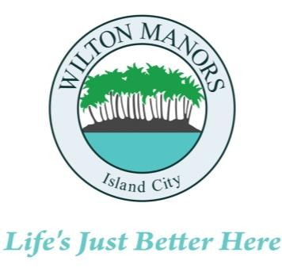
WILTON MANORS
,

Island City

2020
WILTON DRIVE, WILTON MANORS, FLORIDA 33305

COMMUNITY DEVELOPMENT SERVICES
(954) 390-2180
FAX: (954) 567-6069

REGISTRATION OF ABANDONED REAL PROPERTY FORM

In order to comply with Section 13-29(g) of the City of Wilton Manors Code of Ordinances, please complete the required information below in full and submit with your payment of one hundred fifty dollars ($150.00) per property to the City within ten (10) days from the date the property became abandoned.

Address of vacant property:
Folio number of vacant property:
Date acquired property:
.............................................................................................................................................................................

Name of mortgagee:
Direct mailing address of the mortgagee:

Direct contact name:
Telephone number for direct contact:
Fax number for direct contact:
Email address for direct contact:
.............................................................................................................................................................................
In case of a corporation or out-of-area mortgagee, the local property management company responsible for the security and maintenance of the property.

Local property management company:
Direct mailing address of local property management company:
Direct contact name:
Fax number of direct contact:
Email address of direct contact:

Remit payment payable to the City of Wilton Manors and mail to the above address.

Page 1 of 1
Revised 12.22.2025

